|  |
| --- |
| College LaSalle |
| Project - Internet Programming User Manual |
|  |
| Presented to: Mihai Maftei |

|  |
| --- |
| Author: Loveleen Kaur  12/2/2022 |

Describe your application by using print-screen images and a short description (use simple words) to describe what happens (the functionality of…) with each page/button/link/field of your web site.

**Before Login**

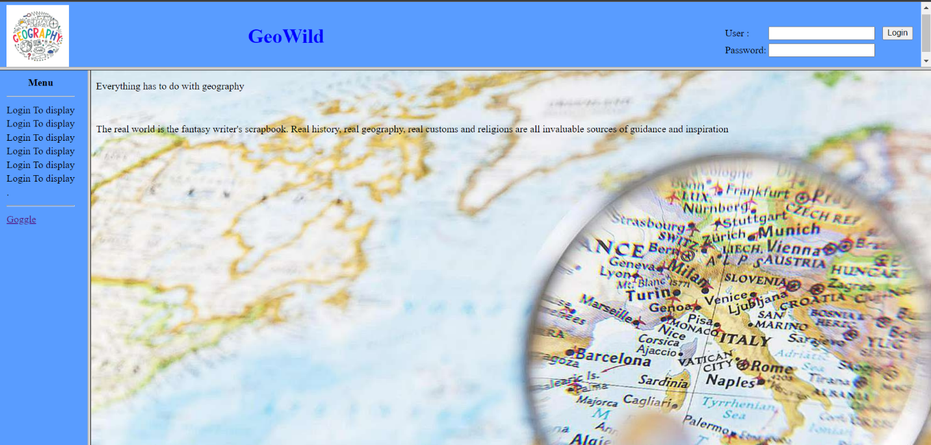

Before login page looks like this.

You need to fill the username, Password to be able to access all the pages otherwise it will show login to display

**When Login**

1. Enter your Username and Password in order to enter to my web site. (**Lkaur@Proj.ca**, **123**)
2. Click on one of the links to have access to different applications.
3. If you click the link of Google, another web page will open, giving you the possibility to search on the internet.

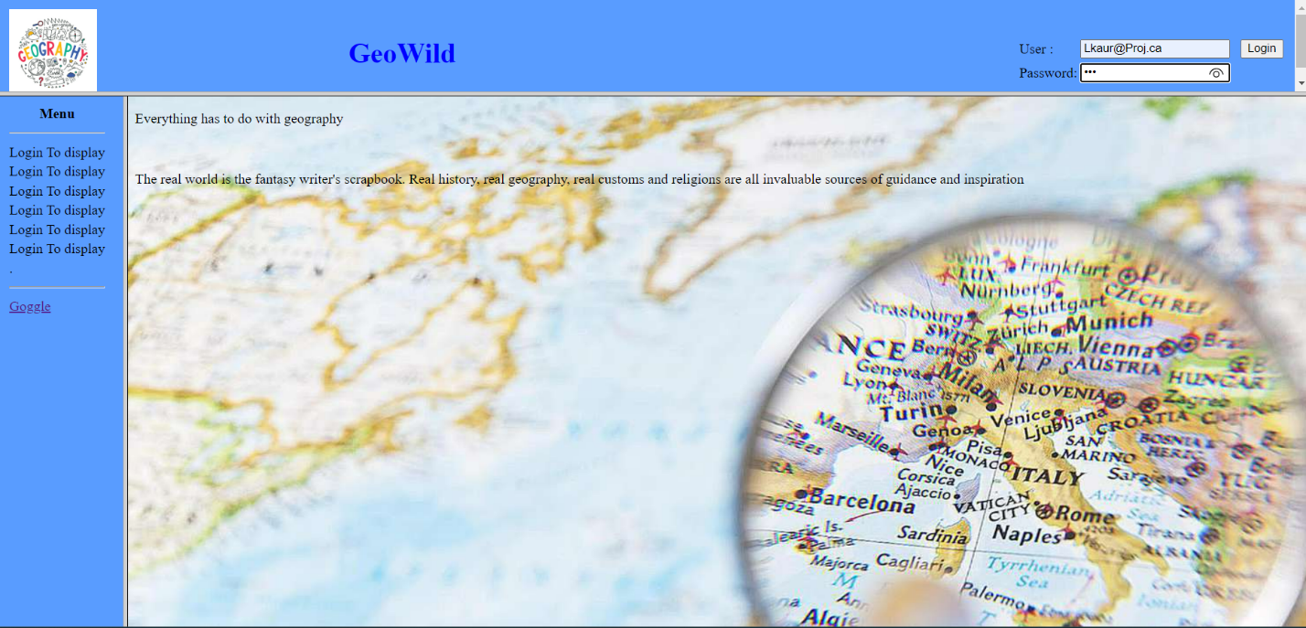

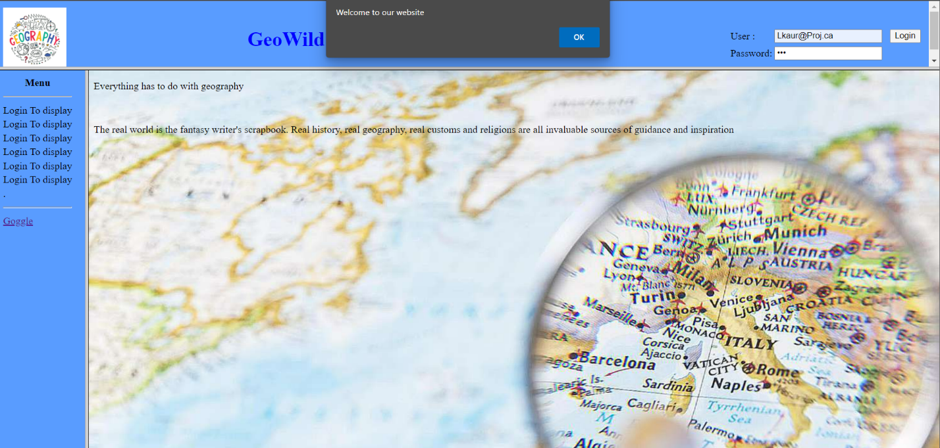

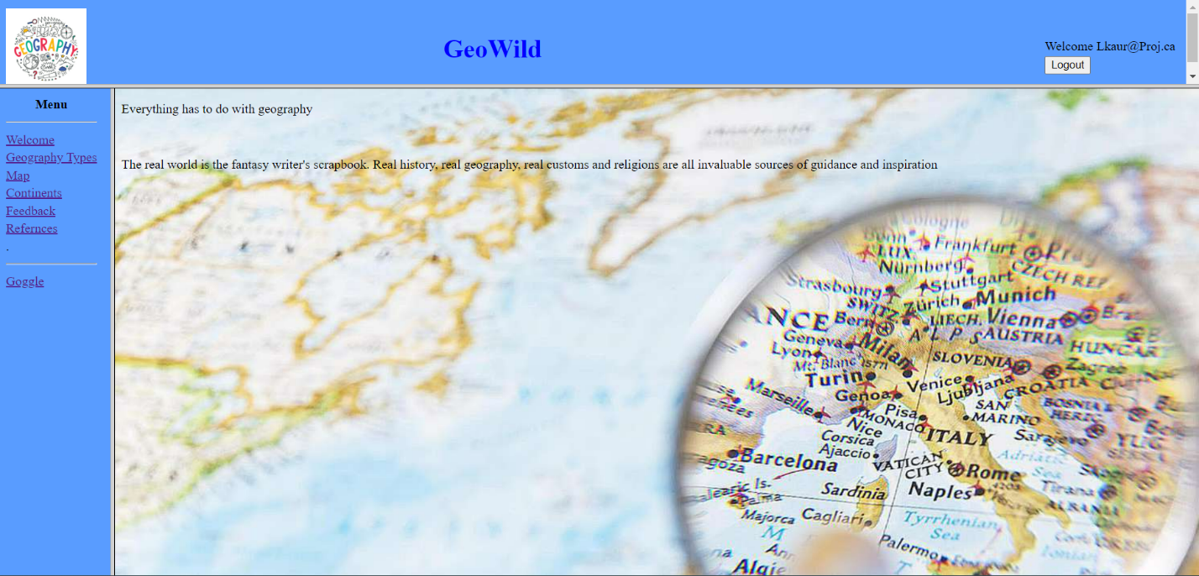

(Note how the contents of menu changed once you logged in)

If User adds wrong information, then an alert is displayed

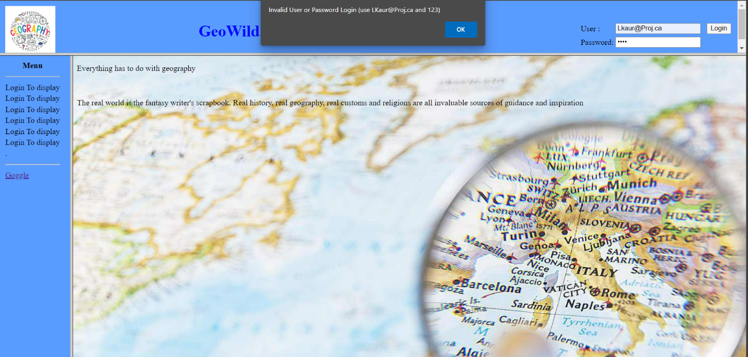

**When Logout**

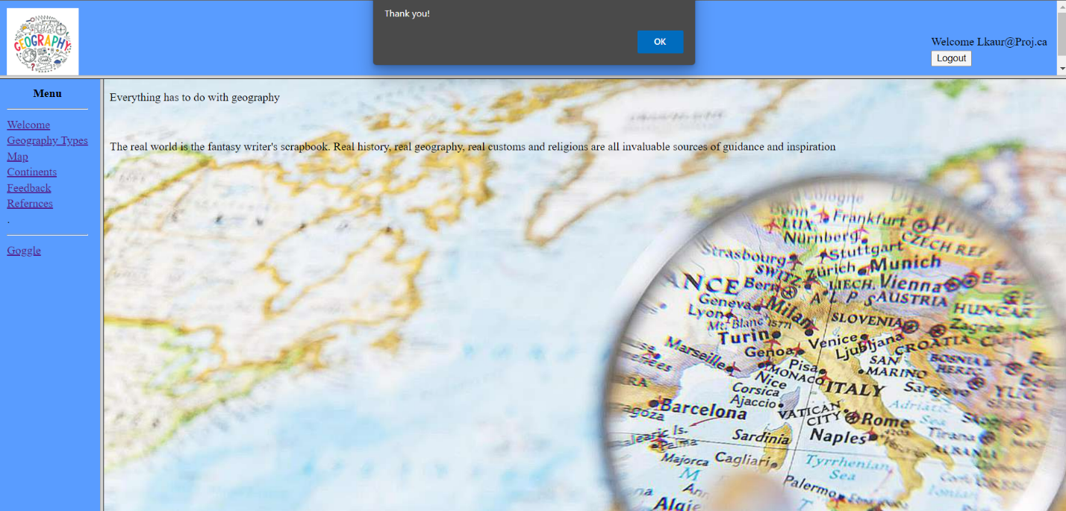

A thank you message appears

AFTER LOGGING-IN

Page1

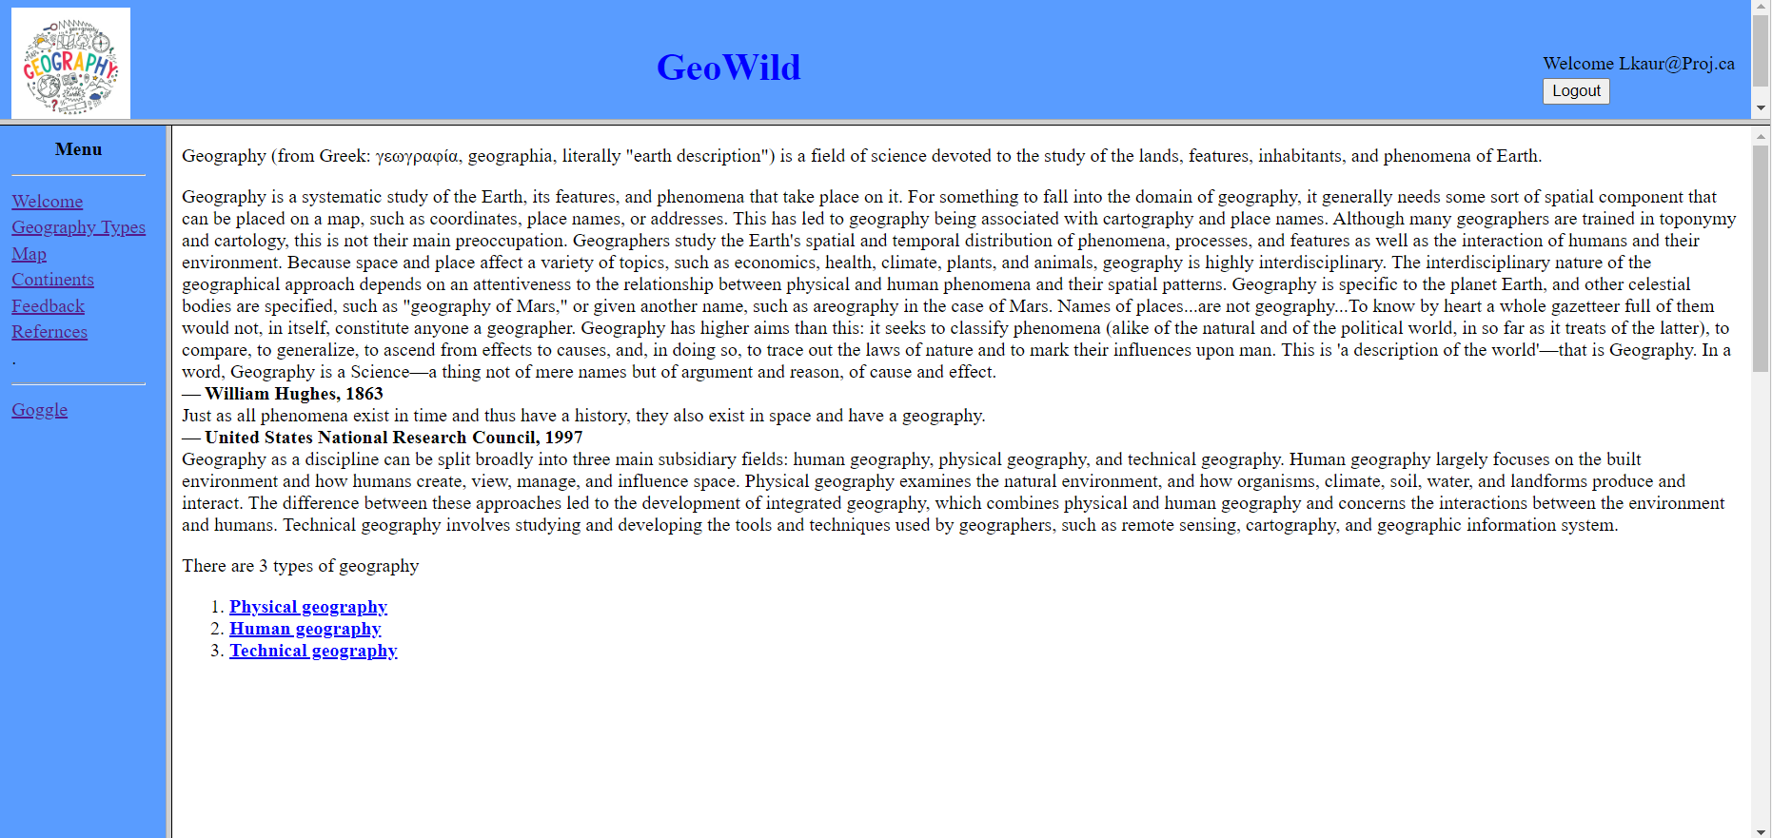

1. Click on any listed items and it will provide you with more information

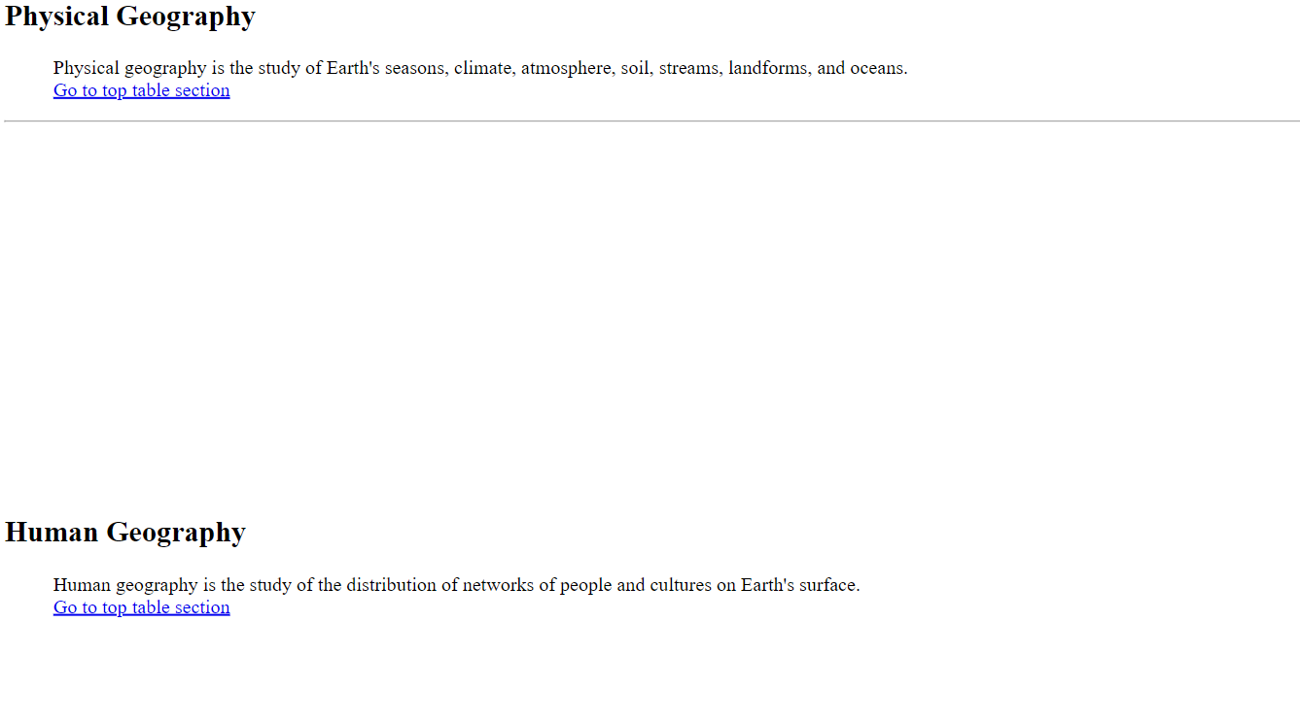

Page2

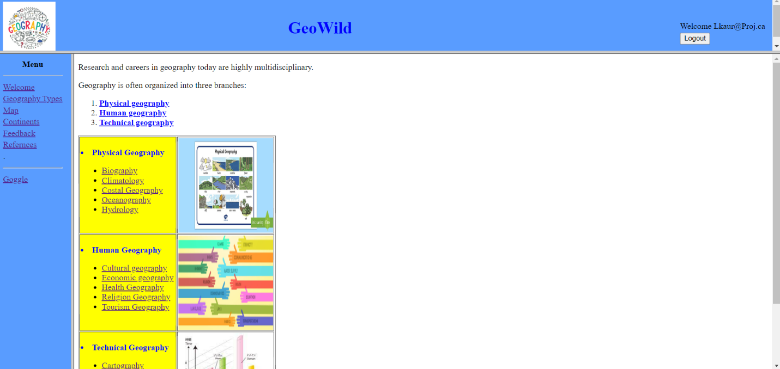

1. Click on any listed item it will be redirected to another web page containing the information

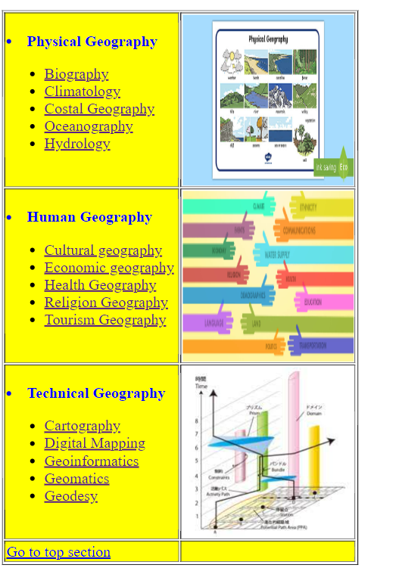

Page3

Click on any of the continent to display more about it.

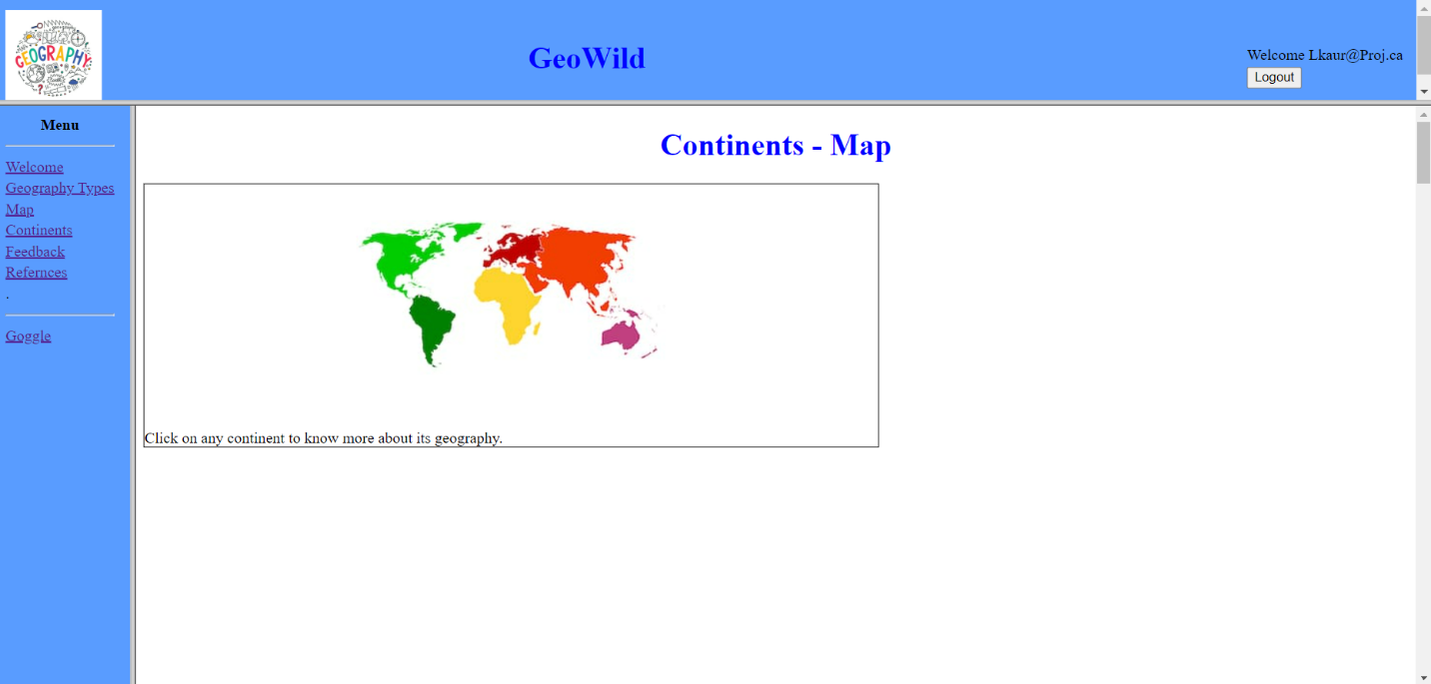

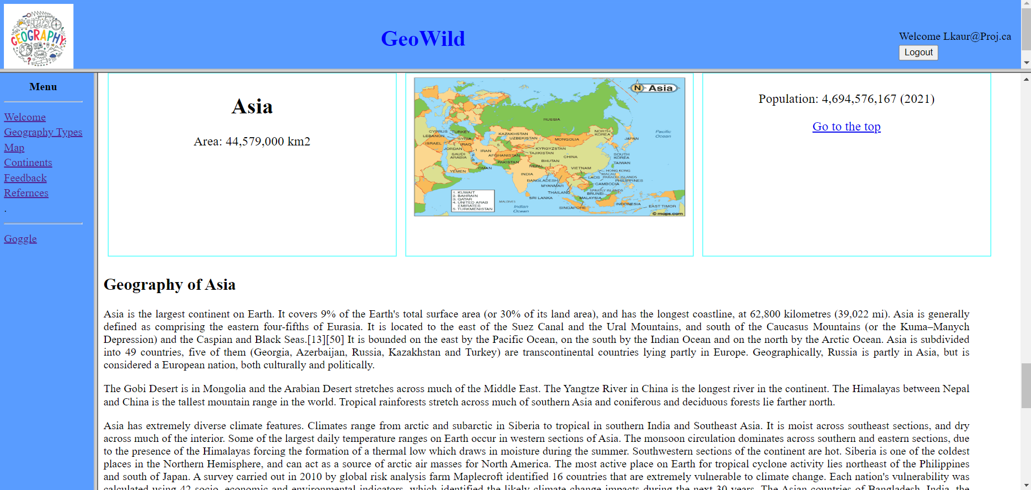

Page4

1. You can either search by clicking a continent in the image or type it in the given field

2. If no continent exist a message will appear

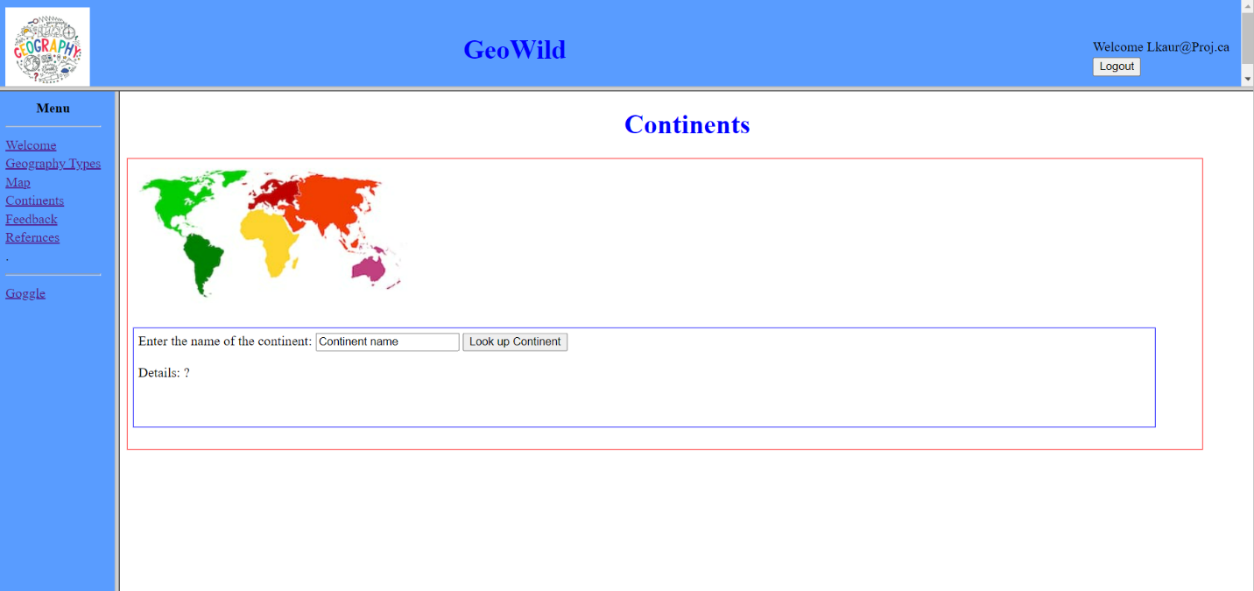

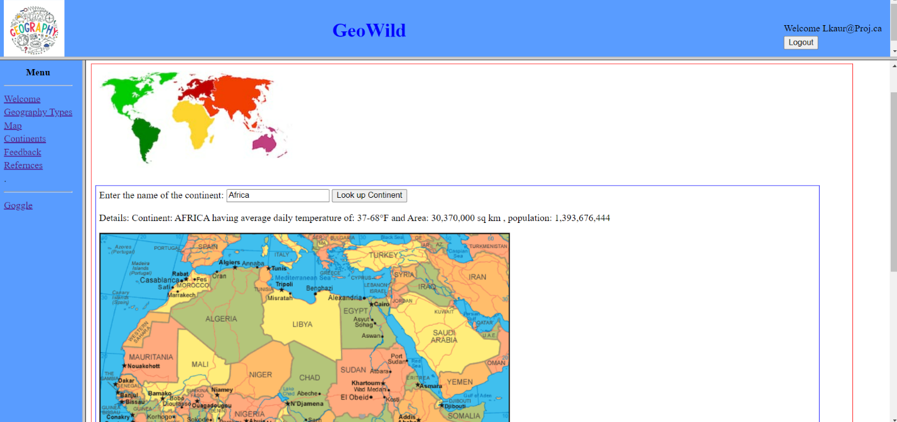

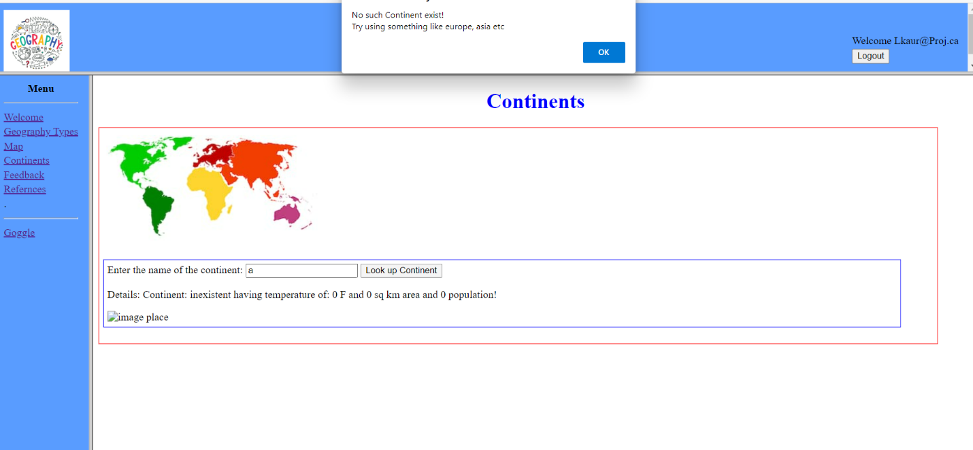

Page5

It contains a form to be filled and when you click submit it shows the taken taken to fill the form

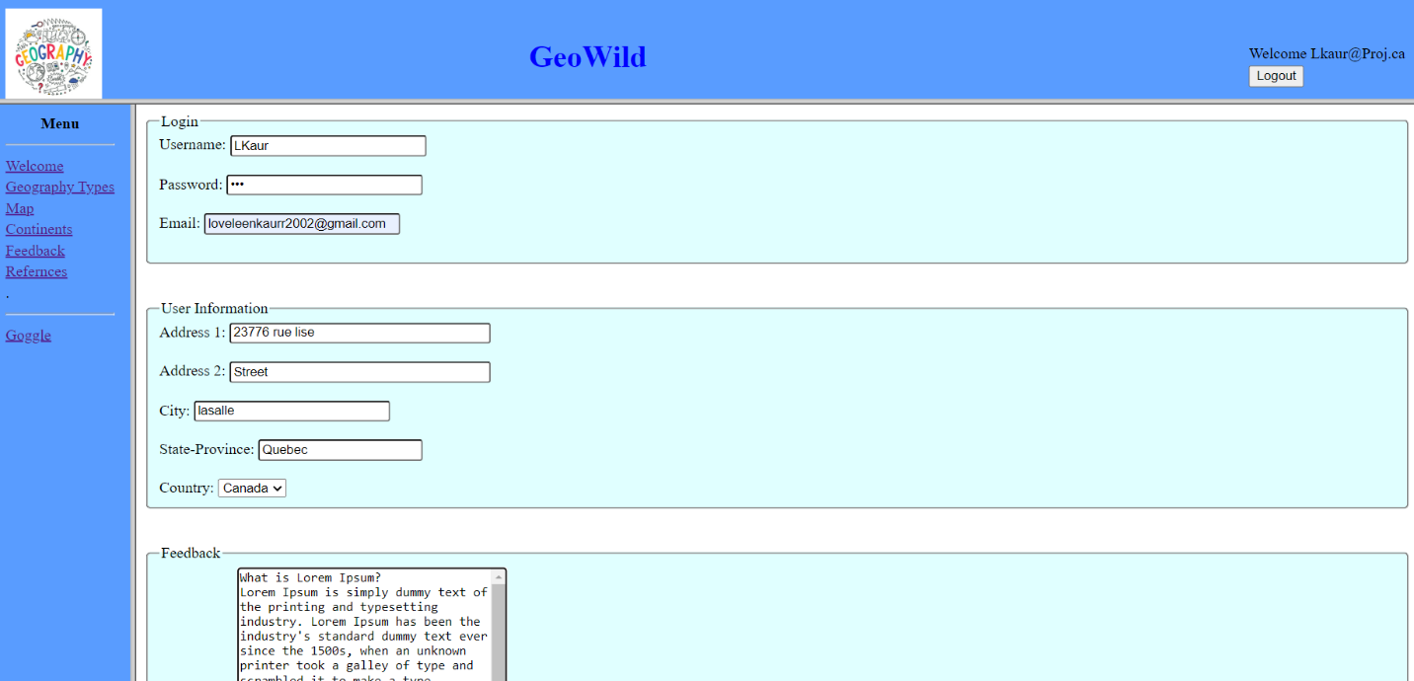

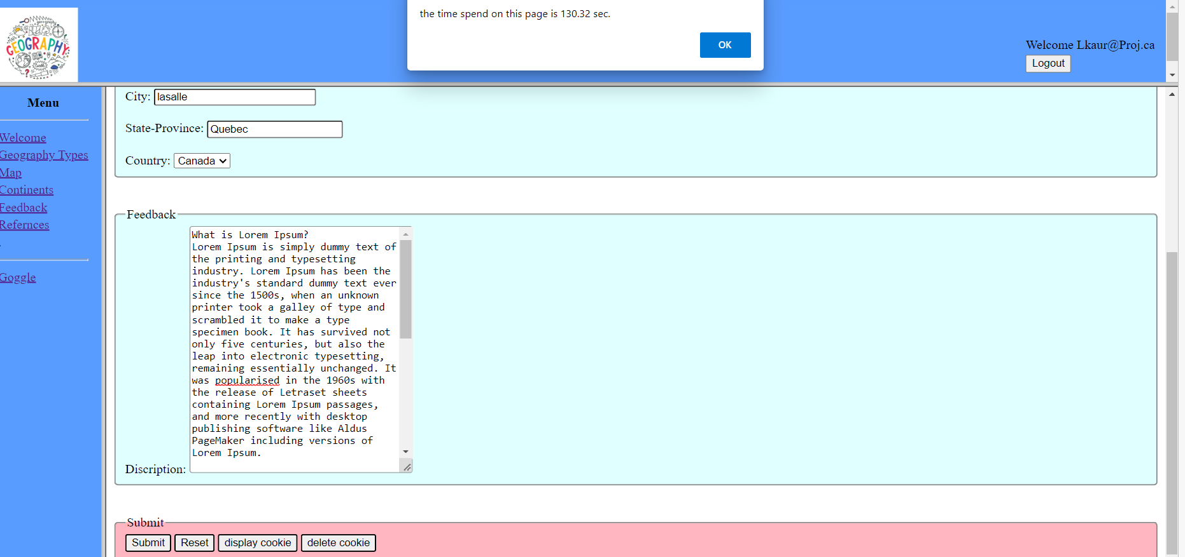

Page6

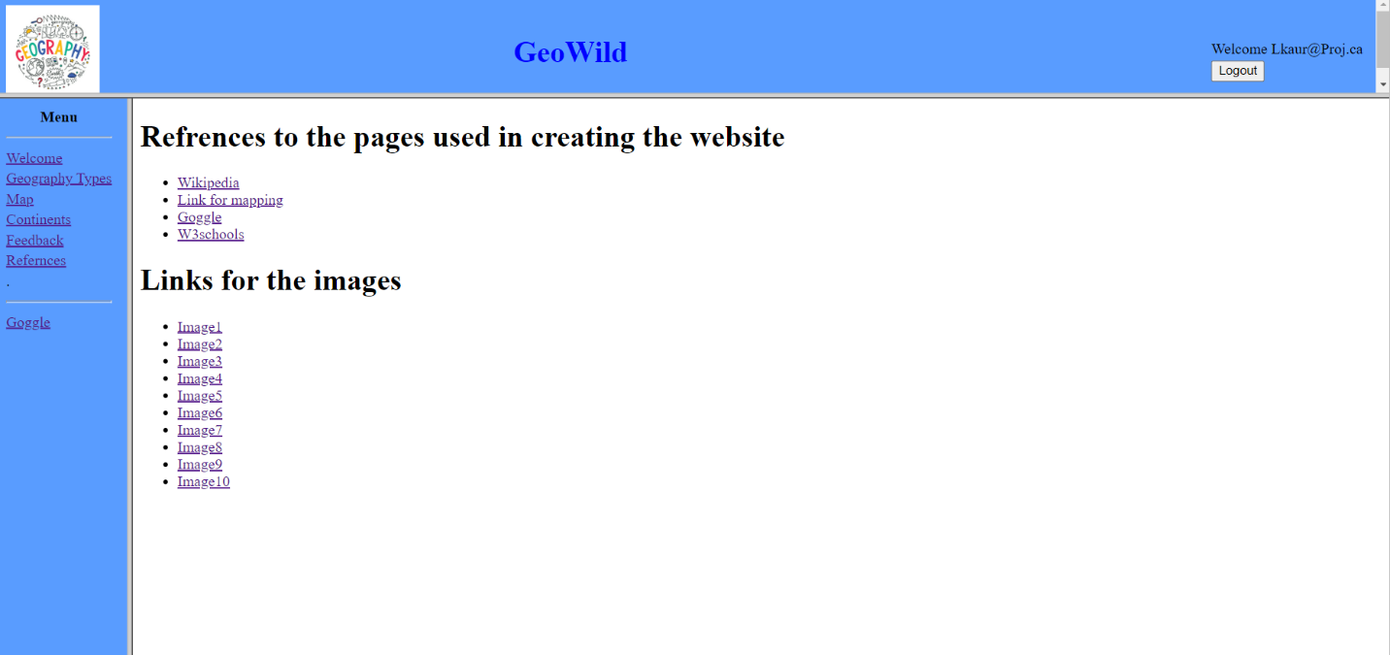

Logout screen

